Order Of Service

Singing: Psalm 2—CW page 65

Reading: Psalm 26

Opening Hymn: TLH 657

Reading: II Corinthians 1:1-11

Request Hymn: CW Supplement 748

Reading: Mark 4:13-20

Sermon Hymn: TLH 658

Sermon Text: Luke 14:1-6

Watching Him Closely

Prayer

The Apostles’ Creed, TLH page 12

Holy Communion

The Lord's Prayer

The Blessing

Closing Hymn: TLH 49

************

Bible Study: Lambs: Eagle
Sheep: Joshua 8—War Against Ai
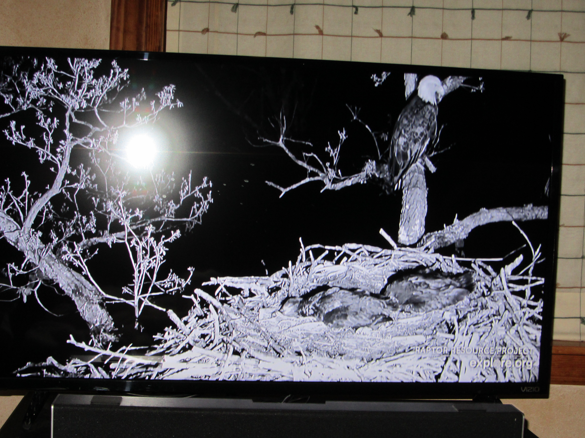

Vigilant Mother Care

Water
Of
Life

12 June 2022

W A T E R O F L I F E

Independent Christian Church—Conservative Lutheran Doctrine

Worship Service: 9:30 a.m.

Larry Cooper, Pastor E-Mail address:
111 N. Ridge Road lcooper@wateroflife.cc
Coon Valley, WI 54623 Web Site:
www.wateroflife.cc

* * * * * * * * * * * * * * * * * * * * * * * * * * *

Sermon Text: Luke 14:1-6

Watching Him Closely

* * * * * * * * * * * * * * * * * * * * * * * * * * *

1 And it came to pass, as he went into the house of one of the chief Pharisees to eat bread on the sabbath day, that they watched him.
2 And, behold, there was a certain man before him which had the dropsy.
3 And Jesus answering spake unto the lawyers and Pharisees, saying, Is it lawful to heal on the sabbath day?
4 And they held their peace. And he took him, and healed him, and let him go;
5 And answered them, saying, Which of you shall have an ass or an ox fallen into a pit, and will not straightway pull him out on the sabbath day?
6 And they could not answer him again to these things.



